**Golden Ham Croquettes**

Makes: 15

Serves: 7

Serving size: 2 croquettes

Prep: 10–15 minutes

Cook: 10–12 minutes

1 lb./455 g ham, large dice

2 tbsp. all-purpose flour

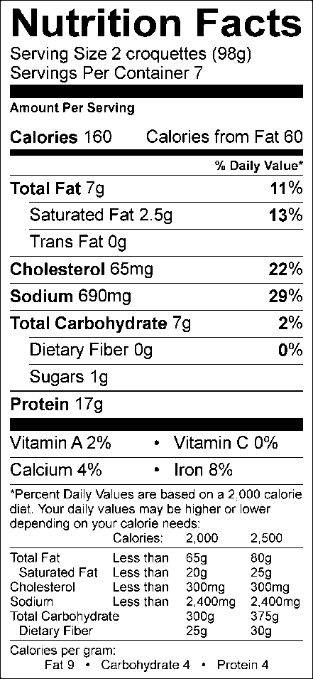½ cup reduced fat (2%) milk

1 egg, lightly beaten

6 tbsp. plain breadcrumbs

canola or olive oil spray

1. Preheat oven to 425° F/218° C
2. Fit Fusion Master™ with fine mincer disc. Place bowl underneath hopper.
3. Fill hopper with diced ham and turn handle to process. Continue to fill hopper with ham until all ham has been processed into bowl.
4. Whisk together flour and milk in 1-Qt./1 L Micro Pitcher. Microwave on high power 20 seconds. Remove and whisk. Microwave an additional 10–20 seconds. Remove and whisk. Repeat as necessary until mixture has thickened and is well combined.
5. Pour milk and flour mixture over ham and stir to combine.
6. Fit M-Press with 3-cylinder nozzle attachment and fill base with ham mixture. Pack the mixture by blocking the nozzle with the Scraper and gently pressing on mixture with Plunger.
7. Remove Scraper and press evenly onto mixture with Plunger to shape ham onto the Guide Sheet.
8. Using the Scraper, cut ham mixture along every bold line printed on Guide Sheet.
9. Roll ham portions in egg, and then the breadcrumbs, before placing on a parchment-lined baking sheet.
10. Spray croquettes with oil and bake 10–12 minutes.

Nutritional Information (per serving):

Calories: 160 Total Fat: 7g Saturated Fat: 2.5g Cholesterol: 65mg Carbohydrate: 7g Sugar: 1g Fiber: 0g Protein: 17g Sodium: 690mg Vitamin A: 2% Vitamin C: 0% Calcium: 4% Iron: 8%