Monkey Bread
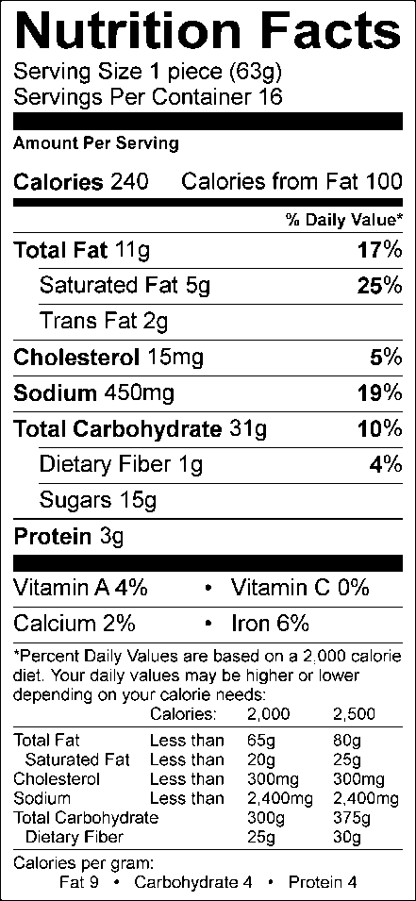
Prep time: 5 minutes
Cook time: 6 minutes
Serves: 16
Serving size: 1 slice, approximately 4–5 biscuit portions

1 stick unsalted butter
2 12-oz./350 g packages refrigerated biscuit dough
1 cup granulated sugar
2 tbsp. Simple Indulgence Cinnamon-Vanilla Seasoning Blend

- Place butter in 1-Qt./1 L Micro Pitcher and microwave on high power 45–60 seconds, or until melted.
- Cut each individual section of biscuit dough into quarters.
- Combine butter and biscuit dough in medium bowl and toss to coat.
- Combine sugar and seasoning blend in Quick Shake® container, and pour over biscuits and butter. Seal bowl and toss to combine. Use Saucy Silicone Spatula to mix, ensuring all biscuits are thoroughly coated.
- Pour biscuits into TupperWave® Stack Cooker 3-Qt./3 L Casserole fitted with Cone.
- Microwave on high power 6 minutes, or until cooked through.
- Allow to cool slightly before turning out onto serving dish.

Nutritional Information (per serving):
Calories: 240 Total Fat: 11g Saturated Fat: 5g Cholesterol: 15mg Carbohydrate: 31g Sugar: 15g Fiber: 1g Protein: 3g Sodium: 450mg Vitamin A: 4% Vitamin C: 0% Calcium: 2% Iron: 6%

