The Facts of Life!

Did you know that after produce is harvested, it is not really “dead”? Think about potatoes for a moment. Don’t they sprout after a certain period of time? Did you know that the yellow broccoli you may have in your fridge is actually a FLOWER? The fruits and vegetables you buy are actually LIVING, METABOLICALLY ACTIVE organisms! And these different products
“behave” differently after harvest, depending upon the stage of development that has been reached. For example, “broccoli is composed of small, immature (undeveloped) flower buds, which would eventually develop into fully mature, yellow pigmented flowers.” Carrots, at the other extreme, are harvested at the end of their growth cycle and will remain in a dormant state for a fairly long period of time.

So what exactly is going on with these “zombies”? They are BREATHING! Yes, that is correct – they are breathing. Specifically, they are converting sugars to generate the energy to continue growing or to maintain their cells, consuming oxygen and producing carbon dioxide. The more immature (or even damaged) the item, the more respiratory activity occurs. Here is a graphic illustration from the research team:
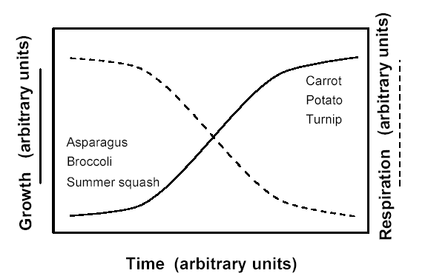

So what does that have to do with whether your broccoli is good or spoiled? Well, in a sealed container, broccoli quickly uses up all the oxygen as it releases carbon dioxide. It actually modifies the atmosphere of the container. Within 24 hours, the optimal oxygen level of 21% declines to only 1 to 2%. In short, your broccoli is suffocating!

Berries, on the other hand, fare best in an atmosphere low in oxygen and high in carbon dioxide. Oxygen is the high-octane fuel needed by botrytis, or gray mold spores. Storing berries in a cold, tightly sealed container, or “atmospherically controlled environment”, will preserve their quality for a longer period of time than in the containers provided at the market.

Tupperware recognized the need to accommodate a wide range of produce, from the heavy breathers like broccoli to the uptight little berries. But how do you do that, since they all have different oxygen requirements? The research team documented that “providing even small ventilation channels…[reduces] problems caused by O2 depletion and CO2 accumulation.” There is a need to ventilate for the high breathrs and to maintain a closed environment for the low breathers.

- ACE/Vent Covers: The most notable difference in the new FridgeSmart™ containers compared to traditional Tupperware, and, frankly, anything else on the market, are the two white vent covers and air vents present on the front of every container. The vent covers can be both open, both closed, or one open and one closed. This innovation creates what is called an Atmosphere Controlled Environment, or ACE, which maintains proper levels of oxygen and carbon dioxide for a wide variety of produce items.
- Integrated grid: Some traditional Tupperware containers featured a separate grid insert to elevate the contents above any condensation in the container. While some moisture is necessary to maintain a desirable crisp texture, direct contact can cause the contents to become soggy and even rot. FridgeSmart™ containers feature a corrugated bottom, inside and out. Inside, the contents are elevated to promote airflow within the container and protection from condensation. Outside, the “grid” promotes airflow around the container, which results in better cooling and preservation.
- Thicker Construction: The research team noted that, particularly in longer containers, there was a problem with air leakage. You may have noticed this with products like the Easy Crisp™ or the Jumbo Bread Server™. They recommended modifying the form of the containers so that they would be more rigid and impermeable. This design change resulted in the thicker walls and seals and the new method of sealing the containers often referred to as “running track”. To seal them, first open a vent cover so that we are not forcing a vacuum into the container. (This would make it very difficult to close the container, and can even result in damage to the seal.) Beginning at the closest edge, press firmly on each of those corners until hearing the confirming clicks, then press firmly along the distance between those corners. Then we press firmly from those closest corners toward the farthest corners, and finally, across the far edge. Last, select the appropriate vent setting. Tupperware also noted that the thickness of the walls and resulting wide seal groove makes the seals easier to clean.
- Modular Design: FridgeSmart™ containers are designed to work together for efficient, organized refrigerator storage. Like Modular Mates™, FreezeSmart™, and even Rock ‘N Serve™, they form a modular system to maximize storage space. Two Mini’s fit atop a Small. A Small and a Medium will fit atop a Large. A Mini and a Medium Long will fit atop a Large. Use the crisper drawer to store soft drinks or canned biscuits, and use the bottom shelf to neatly display your beautiful fruits and vegetables!
- Textured Seal: The top of each seal features a textured “wave” design which minimizes sliding when containers are stacked and complements the design of the bottom grid.
- Translucent Color: Translucent bases enable you to easily identify the contents.
- Dishwasher Safe: All parts are dishwasher safe for easy care. Vent covers are also removable.
- Storage Chart: Each FridgeSmart container has a laser printed vent-setting chart conveniently placed on the side. This chart will never rub off or wear off!

A few storage notes: a Small will hold about a pound of baby carrots. A Medium Long will hold about 2 pounds of grapes. A Large or Large Round will hold HALF of an average watermelon. So who do you want in control – you, an intelligent person, or these zombie vegetables that, if left to their own devices, will modify their environments to their own peril?

Technical information for this document was provided by the Horticultural Sciences Department at the Institute of Food and Agricultural Sciences at the University of Florida, in their report “Behavior of Fruits and Vegetables in Sealed Environment Systems: Influence of Developmental Stage at Harvest, Temperature, and Respiration,” (December 1997)

